ERP test - 10/08/16
SIDE TABLES

Login as Factory1

User
- It is mising the Role field !!! BEING FIXED
- Edit Existing User - Ok
- Create new User (all levels) - OK

Role
- Edit Existing Role - Ok
- Create new Role - Ok

Factory
- Edit Existing Factory - Ok
- Create new Factory - Not available - Ok

Zone
- Missing header filters FIXED
- Edit Existing zone:
- Error when save information - screenshot (0) FIXED
- Error on edit contact, the fields are empty - screenshot (1) FIXED
- Create new zone:
- Error when create contact - screenshot (2) FIXED
- Even all fields with data also Error - screenshot (3) FIXED

Agent
- Missing header filters BEING FIXED
- Edit existing Agent - Ok
- Create new Agent - Not available - Ok

Customer
- Missing header filters FIXED
- Edit existing Customer:
- Edit and save information - Ok
- Error on edit contact, the fields are empty - screenshot (4) FIXED
- Create new Customer - Not available - Ok

Type of customer
- Edit Existing Type Customer - Ok
- Create new Type Customer - Ok

Currency
- Edit Existing Currency - Ok
- Create new Currency - Ok

Currency convert
- Not set up yet

Language
- Edit Existing Language - Ok
- Create new Language - Not available - Ok

Contacts
- Error on access to this page - screenshot (5) FIXED

Login as Zone1

User
- It is mising the Role field !!! BEING FIXED
- Edit Existing User - Ok
- Create new User (all levels) - OK

Role
- Need to hide at this level FIXED LATER
Factory
- Need to hide at this level FIXED LATER

Zone
- Edit Existing zone - Ok
- Create new zone - Not available - Ok

Agent
- Missing header filters BEING FIXED
- Edit existing Agent - Ok
- Create new Agent - Ok

Customer
- Missing header filters BEING FIXED
- Edit existing Customer - Ok
- Create new Customer - Not available - Ok

Type of customer
- Need to hide at this level FIXED LATER

Currency
- Need to hide at this level FIXED LATER

Currency convert
- Need to hide at this level FIXED LATER

Language
- Need to hide at this level FIXED LATER

Contacts
- Error on access to this page - screenshot (5) FIXED

Login as Agent1

User
- It is mising the Role field !!! BEING FIXED
- Edit Existing User - Ok
- Create new User (all levels) - OK

Role, Factory, Zone
- Need to hide at this level FIXED LATER

Agent
- Edit existing Agent - Ok
- Create new Customer - Not available - Ok

Customer
- Missing header filters BEING FIXED
- Edit existing Customer
- Edit and save information - Ok
- Error on edit contact, the fields are empty - screenshot (6) FIXED
- Create new Customer - Ok
(Note: If I edit contact of the new Customer that I have created, then Edit of Contacts works well)

Type of customer, Currency, Currency convert, Language
- Need to hide at this level FIXED LATER

Contacts
- Error on access to this page - screenshot (5) FIXED

Login as Customer3

User, Role, Factory, Zone, Agent, Customer, Type of customer, Currency, Currency convert, Language, Contacts
- Need to hide at this level FIXED LATER

ERP test - 10/08/16
COSTING

Login as Factory1

GROUP OF PRODUCT
- Edit and Create - Ok
- On edit screen, put the description on diferent languages on vertical on the same screen (not on tabs) - Screenshot (7) WILL SUPPORT
- When save, refill with english description the fields which are empty. WILL SUPPORT
TYPE OF PRODUCT
- Edit and Create - Ok
- On main table i want to show code and description on first column, same as on the Edit screen - Screenshot (8) WILL SUPPORT
- On edit screen, put the description on different languages on vertical on the same screen (not on tabs) - Screenshot (8) WILL SUPPORT
- When save, refill with english description the fields which are empty. WILL SUPPORT

On the menu, Move this two pages into COSTING group (now into PRODUCT group). WILL SUPPORT

COST LIST

- Costing List Screen:
- Put header filters BEING FIXED
- Ask for confirmation before delete BEING FIXED
- When edit a Code List, change Customer to blank has to be allowed. Now if any customer is recorded before I can’t make it blank again. BEING FIXED
- Create by Copy
- Works fine but should not copy fields whith “Price List = NO” NEW REQ (complicate issues)
- We need another source, beside of copy from previous Cost Codes we have to be able to copy from Type of Product. NEW REQ – Shift to later (complicate issues, changes a lot)

- Costing Version Information Screen:
- On the header, show english description on Description (Now blank) BEING FIXED
- Put a button to return to Costing information table WILL SUPPORT

ERP test - 10/08/16
PROJECT

Login as Factory1

PROJECT

- Project List Screen
- Project column -50% width BEING FIXED
- Description column +50% width BEING FIXED
- Customer Id -75% width BEING FIXED
- Add Selection of lines selector WILL SUPPORT
- Filter of ACTIONS is nice, but it doesn´t filter properly BEING FIXED

- Create New:
- To select a customer needs a filter to choose it (like in Cost edit) BEING FIXED
- Save button doesn´t works - Screenshot (9) BEING FIXED
- The project number has to be consecutive - Screenshot (9) BEING FIXED

- Project Edit:
- Zone and Agent, Show code and description WILL SUPPORT
- After click on SAVE, close window and return to project list WILL SUPPORT

- Project Comment:
- The imput system is different than all we did before. Maybe we should make as the rest.
- Need more space to read the comments (sometimes can be a text of 15 or 20 lines)
- Make the cell auto-adjustable
- Change order of the comments list. Put last comment on top
(We can comment on our next meeting)
Suggestion:
- Move Project Comment Information to a ne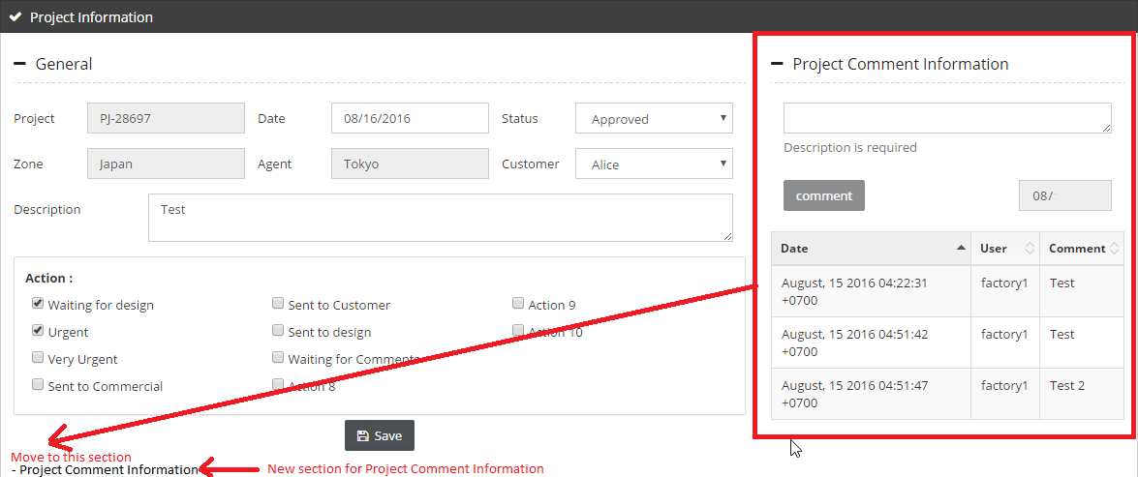w section so that it can have more space

PROJECT STATUS
- We can make a predefined list, no need to make a table for that. ALREADY DONE; LETS JUST USE IT

